**Experiment 9**

**Student Name: Sahul Kumar Parida UID: 20BCS4919**

**Branch: CSE Section/Group: WM-904/B**

**Semester: 5th Date of Performance: 08/11/2022**

**Subject Name: Web and Mobile Security Lab**

**Subject Code: 20CSP-333**

**Aim:**

Develop a Mobile application to create a notification in Android.

**Tools to be used:**

Android Studio.

# Theory/ Discussion

# Android Notification.

Android Notification provides short, timely information about the action happened in the application, even it is not running. The notification displays the icon, title and some amount of the content text.

**Steps/Method/Coding:**

**Activity_main.xml**

Add the following code in an activity_main.xml file.

<?xml version="1.0" encoding="utf-8"?>

<android.support.constraint.ConstraintLayout xmlns:android="http://schemas.android.com/apk/res/android" xmlns:app="http://schemas.android.com/apk/res-auto" xmlns:tools="http://schemas.android.com/tools" android:layout_width="match_parent" android:layout_height="match_parent"

tools:context="example.javatpoint.com.androidnotification.MainActivity">

<TextView android:layout_width="wrap_content" android:layout_height="wrap_content" android:text="ANDROID NOTIFICATION" app:layout_constraintBottom_toBottomOf="parent" app:layout_constraintLeft_toLeftOf="parent" app:layout_constraintRight_toRightOf="parent" app:layout_constraintTop_toTopOf="parent" app:layout_constraintVertical_bias="0.091"

android:textAppearance="@style/Base.TextAppearance.AppCompat.Medium"/>

<Button android:layout_width="wrap_content" android:layout_height="wrap_content" android:id="@+id/button" android:layout_marginBottom="112dp" android:layout_marginEnd="8dp" android:layout_marginStart="8dp" android:text="Notify" app:layout_constraintBottom_toBottomOf="parent" app:layout_constraintEnd_toEndOf="parent" app:layout_constraintStart_toStartOf="parent" />

</android.support.constraint.ConstraintLayout>

Create an activity named as activity_notification_view.xml and add the following code. This activity will be launched on clicking the notification. TextView is used to display the notification message.

**activity_notification_view.xml**

<?xml version="1.0" encoding="utf-8"?>

<android.support.constraint.ConstraintLayout xmlns:android="http://schemas.android.com/apk/res/android" xmlns:app="http://schemas.android.com/apk/res-auto" xmlns:tools="http://schemas.android.com/tools" android:layout_width="match_parent" android:layout_height="match_parent"

tools:context="example.javatpoint.com.androidnotification.NotificationView">

<TextView android:id="@+id/textView2" android:layout_width="fill_parent" android:layout_height="wrap_content" android:gravity="center"

android:text="your detail of notification..."

android:textAppearance="@style/Base.TextAppearance.AppCompat.Medium" />

<TextView

android:id="@+id/textView" android:layout_width="wrap_content" android:layout_height="wrap_content" android:layout_marginBottom="8dp" android:layout_marginEnd="8dp" android:layout_marginStart="8dp" android:layout_marginTop="8dp" app:layout_constraintBottom_toBottomOf="parent" app:layout_constraintEnd_toEndOf="parent" app:layout_constraintHorizontal_bias="0.096" app:layout_constraintStart_toStartOf="parent" app:layout_constraintTop_toBottomOf="@+id/textView2" app:layout_constraintVertical_bias="0.206"

android:textAppearance="@style/Base.TextAppearance.AppCompat.Medium"/>

</android.support.constraint.ConstraintLayout>

**MainActivity.java**

In the MainActivity.java class adds the following code. In this class, clicking the button calls the addNotification() method where we implement the NotificationCompat.Builder object to set the notification properties. The NotificationManager.notify() method is used to display the notification. The Intent class is used to call another activity (NotificationView.java) on taping the notification.

package example.javatpoint.com.androidnotification;

import android.app.NotificationManager; import android.app.PendingIntent; import android.content.Context; import android.content.Intent; import android.support.v4.app.NotificationCompat; import android.support.v7.app.AppCompatActivity; import android.os.Bundle; import android.view.View; import android.widget.Button;

public class MainActivity extends AppCompatActivity {

Button button; @Override

protected void onCreate(Bundle savedInstanceState) { super.onCreate(savedInstanceState); setContentView(R.layout.activity_main); button = findViewById(R.id.button);

button.setOnClickListener(new View.OnClickListener() {

@Override

public void onClick(View v) { addNotification();

}

});

}

private void addNotification() {

NotificationCompat.Builder builder = new NotificationCompat.Builder(this)

.setSmallIcon(R.drawable.messageicon) //set icon for notification

.setContentTitle("Notifications Example") //set title of notification .setContentText("This is a notification message")//this is notification message

.setAutoCancel(true) // makes auto cancel of notification .setPriority(NotificationCompat.PRIORITY_DEFAULT); //set priority of notification

Intent notificationIntent = new Intent(this, NotificationView.class); notificationIntent.addFlags(Intent.FLAG_ACTIVITY_CLEAR_TOP);

//notification message will get at NotificationView

notificationIntent.putExtra("message", "This is a notification message");

PendingIntent pendingIntent = PendingIntent.getActivity(this, 0, notificationIntent,

PendingIntent.FLAG_UPDATE_CURRENT); builder.setContentIntent(pendingIntent);

// Add as notification

NotificationManager manager = (NotificationManager) getSystemService(Context.NOTIFICATION_SERVICE);

manager.notify(0, builder.build());

}

}

**NotificationView.java**

The NotificationView.java class receives the notification message and is displayed in TextView. This class is invoked while taping the notification.

package example.javatpoint.com.androidnotification;

import android.support.v7.app.AppCompatActivity; import android.os.Bundle; import android.widget.TextView; import android.widget.Toast;

public class NotificationView extends AppCompatActivity {

TextView textView;

@Override

protected void onCreate(Bundle savedInstanceState) { super.onCreate(savedInstanceState);

setContentView(R.layout.activity_notification_view); textView = findViewById(R.id.textView);

//getting the notification message

String message=getIntent().getStringExtra("message"); textView.setText(message);

}

}

strings.xml <resources>

<string name="app_name">AndroidNotification</string>

<string name="notification_activity">NotificationView</string>

</resources>

**AndroidManifest.xml**

Add the following code in AndroidManifest.xml file.

<?xml version="1.0" encoding="utf-8"?>

<manifest xmlns:android="http://schemas.android.com/apk/res/android" package="example.javatpoint.com.androidnotification">

<application android:allowBackup="true" android:icon="@mipmap/ic_launcher" android:label="@string/app_name" android:roundIcon="@mipmap/ic_launcher_round" android:supportsRtl="true" android:theme="@style/AppTheme"> <activity android:name=".MainActivity">

<intent-filter>

<action android:name="android.intent.action.MAIN" />

<category android:name="android.intent.category.LAUNCHER" />

</intent-filter>

</activity>

<activity android:name=".NotificationView" android:label="@string/notification_activity" android:parentActivityName=".MainActivity">

<meta-data

android:name="android.support.PARENT_ACTIVITY"

android:value=".MainActivity"/>

</activity>

</application>

</manifest>

**Output:**

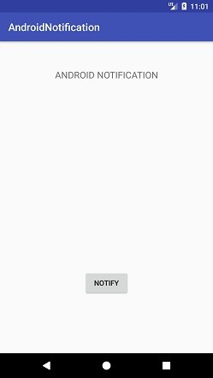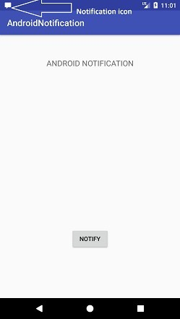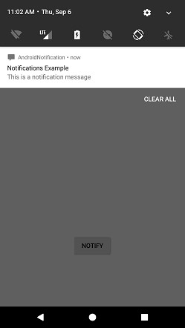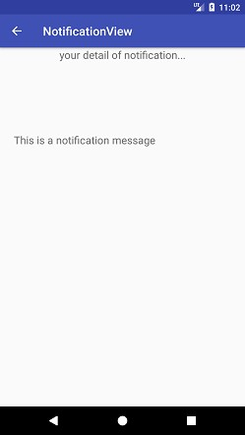

**Learning Outcomes:**

Output is often known as hash values, hash codes, message digest. The length of output hashes is generally less than its corresponding input message length.